

CSE3009-Internet Of Things

Guided by: Prof. Priya G

Project title:

**ADAPTIVE ZONAL BASED IRRIGATION SYSTEM**

Group members:

1. Vipul Goel (16BCI0115)

Type of Components used in our project

1) Input (Humidity)

2) Output (LCD Display)

3) Sensor(Soil Moisture sensor)

4) Actuator(5-6V Pump)

5) Programmable Device(Arduino)

1. INPUT

In our project we are taking the amount of Moisture Level in soil.When the Moisture Level is below a certain level the Pump is triggered else Pump is switched OFF.

1. OUTPUT

To display the amount of Moisture in the soil by using LCD1602 with I2C Arduino Adaptor

a.LCD1602 display

FEATURES

-Display Mode: STN, BLUB

-Display Formate: 16 Character x 2 Line

-Viewing Direction: 6 O’Clock

-Input Data: 4-Bits or 8-Bits interface available

-Display Font : 5 x 8 Dots

-Power Supply : Single Power Supply (5V±10%)

-Driving Scheme : 1/16Duty,1/5Bias

b.I2C Arduino Adaptor

I2C bus is a type of serial bus invented by PHLIPS. It is a high performance serial bus which has bus ruling and high or low speed device synchronization function required by multiple-host system. The blue potentiometer on the I2C LCD1602 (see the figure below) is used to adjust the backlight for better display. I²C uses only two bidirectional open-drain lines, Serial Data Line (SDA) and Serial Clock Line (SCL), pulled up with resistors.

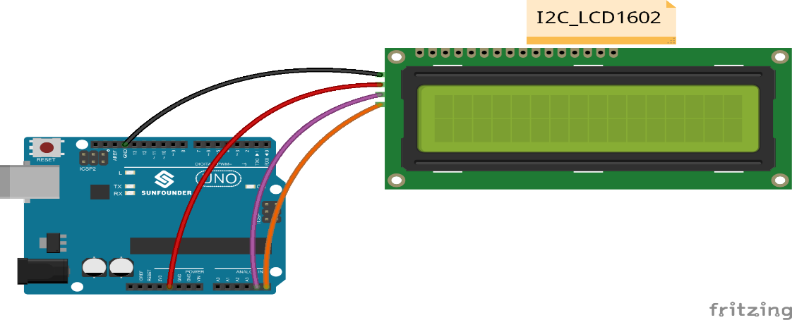

3) Sensor(Soil Moisture Sensor)

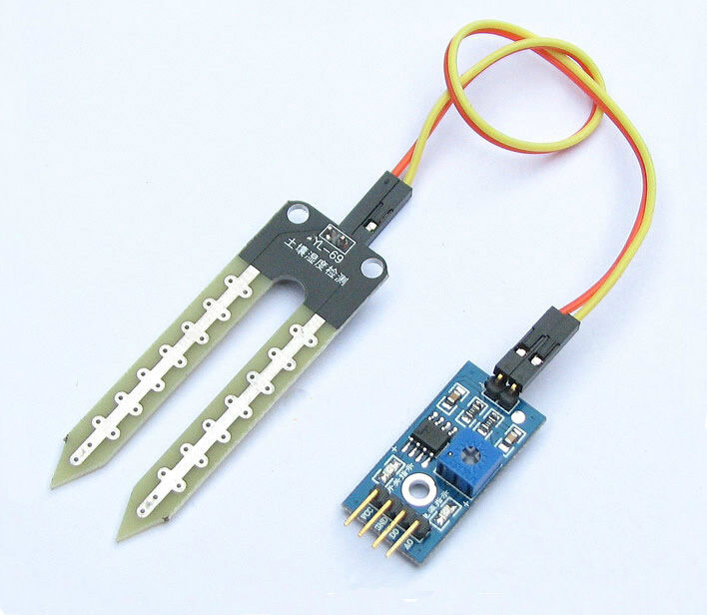Soil moisture sensors measure the volumetric [water content](https://en.wikipedia.org/wiki/Water_content) in [soil](https://en.wikipedia.org/wiki/Soil). Since the direct [gravimetric measurement](https://en.wikipedia.org/wiki/Gravimetric_analysis) of free soil moisture requires removing, drying, and weighting of a sample, soil moisture sensors measure the volumetric water content indirectly by using some other property of the soil, such as electrical resistance, dielectric constant, or interaction with [neutrons](https://en.wikipedia.org/wiki/Neutron), as a proxy for the moisture content. The relation between the measured property and soil moisture must be calibrated and may vary depending on environmental factors such as soil type, [temperature](https://en.wikipedia.org/wiki/Temperature), or [electric conductivity](https://en.wikipedia.org/wiki/Electric_conductivity). Reflected [microwave](https://en.wikipedia.org/wiki/Microwave) radiation is affected by the soil moisture and is used for [remote sensing](https://en.wikipedia.org/wiki/Remote_sensing) in [hydrology](https://en.wikipedia.org/wiki/Hydrology) and agriculture. Portable probe instruments can be used by farmers or gardeners.

Soil moisture sensors typically refer to sensors that estimate volumetric water content. Another class of sensors measure another property of moisture in soils called [water potential](https://en.wikipedia.org/wiki/Water_potential); these sensors are usually referred to as soil water potential sensors and include [tensiometers](https://en.wikipedia.org/wiki/Tensiometer_%28soil_science%29) and gypsum blocks.

LM393 Driver:

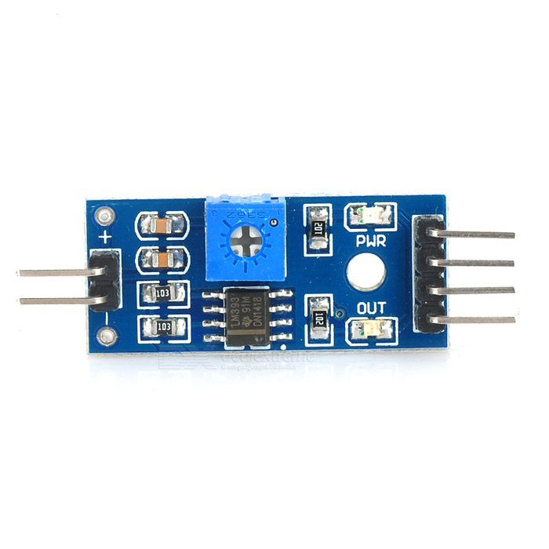LM393 device consist of two independent low voltage comparators designed specifically to operate from a single supply over a wide range of voltages.Operation from split power supplies is also possible.These comparators also have a unique characterstic in that the input common-mode voltage range includes ground even though operated from a single power suppy voltage.

Working:

Soil moisture sensors measures the water content in soil.A soil moisture probe is made up of multiple soil moisture sensors.One common type of soil moisture sensors commercial use of frequency domain sensors such as a capacitance sensor. Another sensor,the neutron moisture gauge,utilises the moderator properties of water for neutrons.Soil moisture content may be determined via its effect on dielectric constant by measuring the capacitance between two electrodes implanted in the soil. Where soil moisture is predominantly in the form of free water ,the dielectric constant is directly proportional to the moisture content. The probe is normally given a frequency excitation to permit measurement of the dielectric constant. The readout from the probe is not linear with water content and is influenced by soil type and soil temperature. Therefore,careful calibration is required and long term stability of the calibration is questionable.

4) Arduino board.

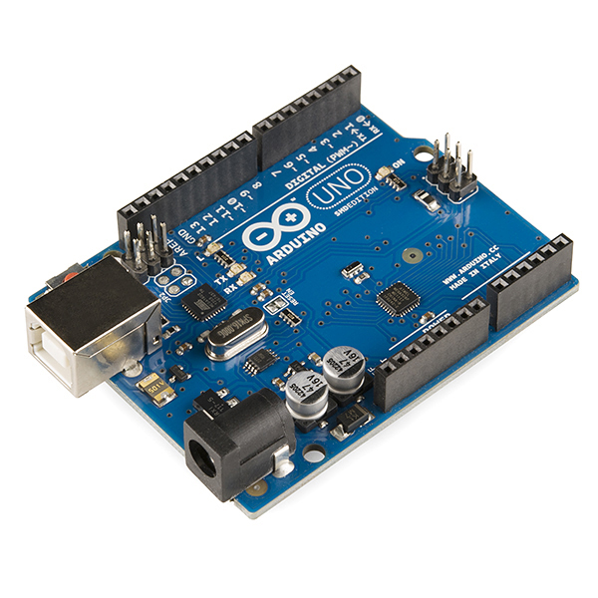Arduino board designs use a variety of microprocessors and controllers. The boards are equipped with sets of digital and analog [input/output](https://en.wikipedia.org/wiki/Input/output) (I/O) pins that may be interfaced to various expansion boards (*shields*) and other circuits. The boards feature serial communications interfaces, including [Universal Serial Bus](https://en.wikipedia.org/wiki/Universal_Serial_Bus) (USB) on some models, which are also used for loading programs from personal computers. The microcontrollers are typically programmed using a dialect of features from the programming languages [C](https://en.wikipedia.org/wiki/C_%28programming_language%29) and [C++](https://en.wikipedia.org/wiki/C%2B%2B). In addition to using traditional compiler tool chains, the Arduino project provides an [integrated development environment](https://en.wikipedia.org/wiki/Integrated_development_environment) (IDE) based on the [Processing](https://en.wikipedia.org/wiki/Processing_%28programming_language%29) language project.

5) Actuator(5-6v Pump)

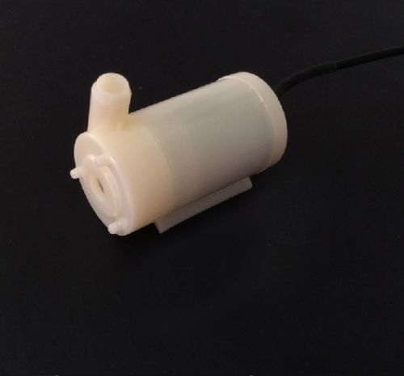 An actuator is a component of a machine that is responsible for moving or controlling a mechanism or system.Here we ae using a pump as an actuator to control the movement of water for irrigation

An actuator requires a control signal and a source of energy. Here the signal is provided by the moisture sensor. The supplied main energy source may be [electric current](https://en.wikipedia.org/wiki/Electric_current). When the control signal is received, the actuator responds by converting the energy into mechanical motion.

6) Communicator(RF Module)

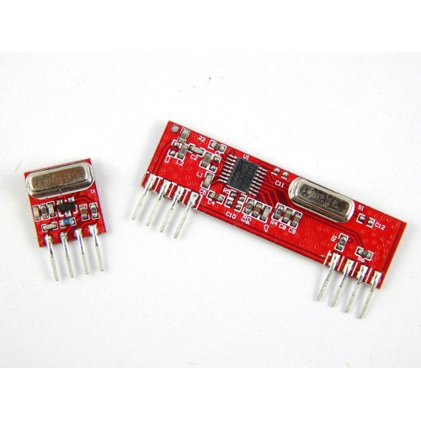An **RF module** (radio frequency module) is a (usually) small electronic device used to transmit and/or receive radio signals between two devices. In an [embedded system](https://en.wikipedia.org/wiki/Embedded_system) it is often desirable to communicate with another device [wirelessly](https://en.wikipedia.org/wiki/Wireless). This wireless communication may be accomplished through [optical communication](https://en.wikipedia.org/wiki/Free-space_optical_communication) or through [radio](https://en.wikipedia.org/wiki/Radio) frequency (RF) communication. For many applications the medium of choice is RF since it does not require line of sight. RF communications incorporate a [transmitter](https://en.wikipedia.org/wiki/Transmitter) or [receiver](https://en.wikipedia.org/wiki/Receiver_(radio)).